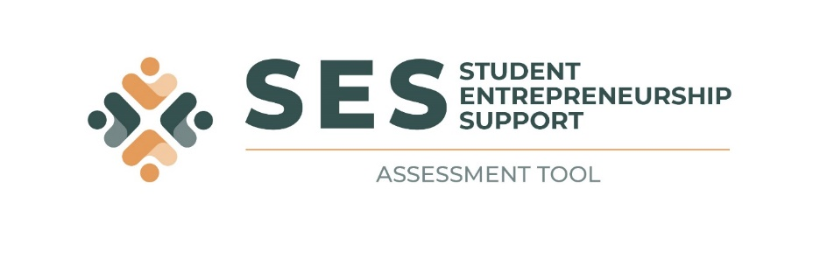
INSERT YOUR UNIVERSITY LOGO HERE

Implementing a Student Entrepreneurship Support (SES) Assessment Tool at [Insert the name of your University here]

Dear [Insert the name of your university here] staff members and students

South Africa experiences some of the highest levels of unemployment in the world. This is particularly problematic for the youth and for graduating students. Entrepreneurship in general, including student entrepreneurship, is seen as providing a solution to these high levels of unemployment. However, because the number of student start-ups in South Africa remains stagnant, the effectiveness of university-based student entrepreneurship support is questioned.

Against this background, the stakeholders at [Insert the name of your university here] want to take steps to improve the support offered to student entrepreneurs at this university. To do so, they need to understand and assess the existing support available. This first step involves implementing a tool to assess student entrepreneurship support which has been developed as an international collaborative project between Nelson Mandela University, the University of Pretoria and Ghent University, funded by VLIR-UOS.

We invite all current staff members and students at [Insert the name of your university here] to access the SES Assessment Tool and to complete the survey. This will enable student entrepreneurship support stakeholders to improve the type and quality of support given to entrepreneurial students at our university.

The ethical integrity of the SES Assessment Tool has been subjected to the procedures of the Research Ethics Committee (Human) of [Insert the name of your university here]. The ethics clearance number of this study is [Insert your ethics number obtained] and the regulatory authority is [Insert the relevant name of the person at your university here], (Insert the persons contact details here). Any ethical queries, complaints or concerns relating to this study can be directed to the researchers (see contact details below) and [Insert the relevant name of the person at your university here], the REC-H Chair (Insert the persons contact details here). Thereafter, they can be directed to the National Research Ethics Council. Please find more detail regarding the project and the ethical considerations in the letter attached.
If you are interested in and willing to participate in this survey, please follow this link: https://mandela.questionpro.com/ses-assessment-tool.

You are welcome to request a report on the results of the survey via the SES Assessment Tool website (https://student-entrep-support.co.za/). If you do so, the report will be sent to your university email address after the survey period of four weeks is over.

Thank you for your assistance.

Kind regards

[Insert the relevant name and contact details here]

